# Fixed Income Portfolio Management

## Codebase & Collaboration

The entire project codebase is hosted on GitHub, enabling seamless collaboration between team members across locations (e.g., colleagues in London).

Repository URL:  
 🔗<https://github.com/TickooAkash/FixedIncome_BlackRock>

## Cloning the Repository

Follow these steps to set up the project locally:

# 1. Check if git is installed

git --version

# 2. Go to the folder where you want the repo

cd ~/projects

# 3. Clone the repo from GitHub

git clone https://github.com/TickooAkash/FixedIncome_BlackRock.git

# 4. Move into the cloned repo folder

cd FixedIncome_BlackRock

# 5. (Optional) Check what branch you’re on

git branch

# 6. (Optional) Pull latest changes if you already cloned before

git pull origin main

## Project Structure

* All source code is located in the src folder:  
  + portfolioHoldingDataCleaning.py → responsible for data cleaning.
  + portfolioAnalysis.py → contains the portfolio analysis logic.
  + streamlitApp.py → Streamlit front-end application.
  + exportAnalysis.py → generates exports for Power BI / Tableau dashboards.
* All data files are stored under the data folder:  
  + raw/ → contains the input file Portfolio_holdings.xlsx.
  + clean/ → contains cleaned outputs:  
    - PORT_EUR_clean.csv (EUR portfolio)
    - PORT_USD_clean.csv (USD portfolio)
  + exports/ → contains all exported CSV files used for Power BI dashboards.
* The Power BI folder contains the .pbix file, which can be opened in Power BI Desktop to view the interactive report.
* The requirements.txt file lists all required Python dependencies for the project.
* Portfolio_Insights.ppt - Presentation to the stake holders.

Role and sequence of run:

1. portfolioHoldingDataCleaning.py → Cleans the raw Excel file, standardizes columns (e.g., Market Value, KRDs), splits into USD & EUR portfolios, and saves them as cleaned CSVs for further analysis.
   1. output -

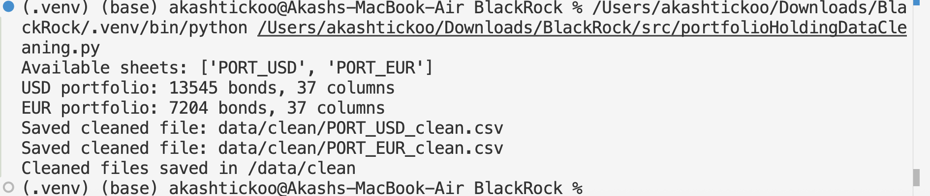

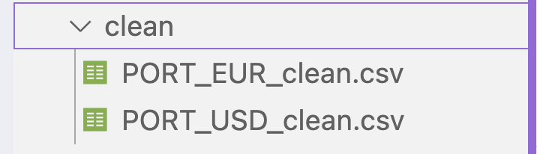

1. portfolioAnalysis.py → Performs portfolio analytics on the cleaned CSVs, including credit distribution, sector exposure, KRD profile, top holdings, duration, maturity buckets, and currency exposure. Outputs results for both USD & EUR portfolios.
   1. Sample output -

| === Portfolio Summaries ===  Portfolio ... Average Maturity (yrs)  0 USD Portfolio ... 12.859624  1 EUR Portfolio ... 5.946394  [2 rows x 4 columns]  === Composite Credit Distribution (USD) ===  Composite Rating  A 2.976311  A+ 2.031056  A- 3.338188  A1 0.063380  A2 0.012461  A3 0.077306  AA 0.341838  AA+ 69.785848  AA- 2.516120  AAA 2.233037  Aa1 0.019142  Aa2 0.017444  Aa3 0.017030  Aaa 0.239360  Agency 0.014954  BB+ 0.103889  BB- 0.001938  BBB 3.624841  BBB+ 2.497247  BBB+(E 0.001134  BBB- 2.156656  Baa1 0.069712  Baa2 0.049299  Baa3 0.035001  NR 7.046718  UNK 0.010327  WD 0.719763  Name: Market Value, dtype: float64  …..  ….  …  So on |
| --- |

3.streamlitApp.py → Provides a simple Streamlit front-end where users view key analytics (summary stats, credit distribution, sector exposure, KRD profile, etc.) interactively in a web browser.

| Command to run streamLit app  streamlit run src/[streamlitApp.py](http://streamlitapp.py)  Control C to stop the local server |
| --- |

Sample UI Output -

|  |
| --- |

1. exportAnalysis.py → Runs the portfolio analysis and **exports results into multiple CSV files** (summaries, credit distributions, sector exposure, KRD profile, top holdings, maturity buckets, etc.). These CSVs, stored in the data/exports/ folder, are used for building dashboards in Power BI.
   1. output

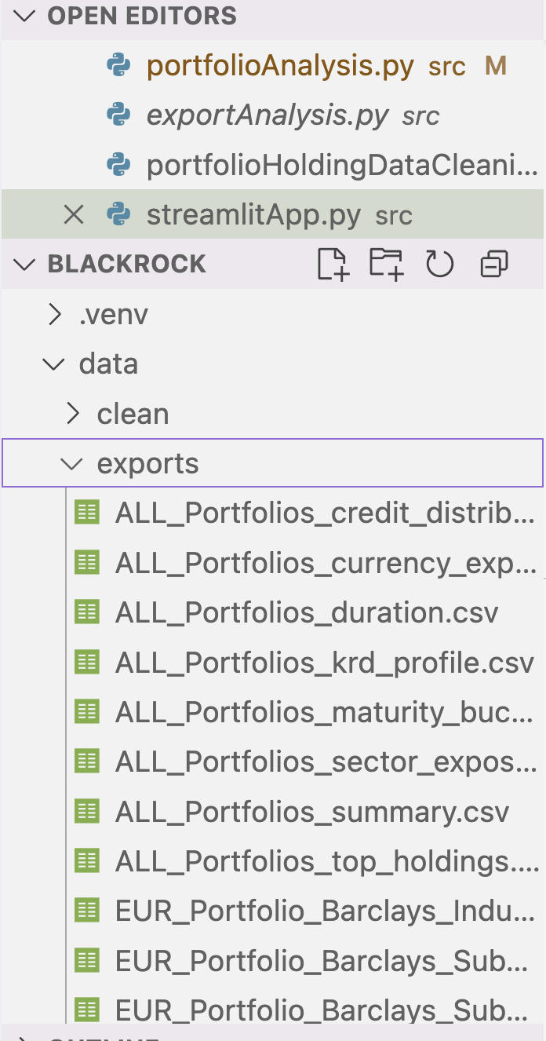

These files are imported in powerBi dashBoard.

Power BI Dashboard screenShots ➖

